Can baijiu, China’s sorghum firewater, go global?
An ancient liquor tries to follow vodka and tequila- Print edition | China Feb 2nd 2019| MAOTAI
Distillers at Kweichow Moutai, the world’s most valuable alcoholic-drinks firm, like to tell an old story about their company’s first big break. It relates how, in 1915, Chinese officials chose to exhibit Moutai’s sorghum-based spirit at an exposition in San Francisco. When the doors opened the snooty American audience sneered at the delegation’s plain earthenware jars. Fearing disaster, or perhaps simply by accident, a Chinese delegate smashed one on the floor, releasing its aroma to the crowd. The scent and the commotion attracted the judges, who eventually awarded it a top prize. The tale is told with relish to visitors in Maotai, the pretty riverside town in the south-western province of Guizhou that gave the company its name (the spelling of Kweichow Moutai is based on old-style romanisation). The medal the liquor won in San Francisco hangs in a corporate museum, next to a video-wall showing a re-enactment of the incident. That was the day, explains the exhibit, that the brand “went global”. Down a hill, in the heart of the town, is a plaza named “1915 Square” that hums with visitors. At its centre is a giant gold-painted monument in the shape of a cracked liquor jar. That the company should take such pride in this bygone foreign endorsement is odd, given how much it has to celebrate at home. Moutai has long called itself the “national liquor”—though last year it gave up a years-long battle to trademark this description. Feted by Communist leaders who often serve it to visiting dignitaries, Moutai is among the most expensive of the brands of baijiu (literally meaning white, or clear, alcohol) that are commonly bought to celebrate the Chinese new year, which this year begins on February 5th. The festival is a frenzy of baijiu imbibing and gift-giving among family and friends. The liquor—a broad family of grain-based spirits selling for anything between a few dollars and a few thousand dollars per bottle—is the most-drunk spirit on earth. But this is only by dint of its popularity in China. Each year drinkers there spend about three times more on baijiu than they do on beer and roughly 15 times more than on wine. The 10bn litres produced each year is more than twice the annual global production of vodka, the next most popular spirit. It would fill a bath for every person in Britain. In 2017 Moutai’s market capitalisation reached $71.5bn, overtaking that of Diageo, a British drinks giant. Over the years Europeans and Americans have grown to love vodka, a once-obscure Russian gut-rot, and tequila, a Mexican drink made from spiky plants. But Chinese liquor firms have made few inroads globally. About 95% of Moutai’s sales are in China. So it is remarkable that the company tries to suggest that it has had a century of success abroad. Only recently have it and some of China’s thousands of other baijiu-makers begun stepping up efforts to develop foreign markets. This will be a challenge. To unaccustomed palates, baijiu can be an assault on the senses. The primary ingredient is sorghum, or sometimes rice. In contrast with the making of whisky or beer, the grains are usually fermented while solid. This requires them to be mixed with a yeast-filled agent and then heaped in mounds, packed in buried jars or sometimes sealed pits. When the solid mixture is suitably stinky it is distilled by heating in a still that operates like a steamer (see picture), to produce high-alcohol liquid. Production of the simplest type can be completed in a week or two. More complex ones require multiple fermentations and distillations that can take up to nine months. In either case, the spirit is eventually aged in ceramic jars as tall as a human being.
What results is a startling variety of products, many with an alcohol content above 50%. At its most drinkable, it is sweet, aromatic and has a vodka’s crispness. At its most pungent it can be a punchy mix of mushrooms, liquorice and old socks. Connoisseurs divide the drink by flavour into four categories: rice, light, strong and sauce. But it is rarely consumed for its subtleties. It is more a social lubricant, usually drunk at mealtimes with family, colleagues or clients. It is downed in shots rather than sips. Endless toasting can turn banquets into tests of endurance.
In the workshop of a small, independent baijiu distillery in Maotai, shirtless men rake out hot piles of sorghum that they have tipped from steaming wheelbarrows. Zhao Liyong, the owner, hops perilously around the lip of an empty fermentation pit, a brick-lined hole that looks about six feet deep. He still makes the drink the way his grandfather did. Later, over a plate of pork intestines, his tongue loosened by a bottle of his own liquor, Mr Zhao lists some of his product’s magical properties: it can treat ulcers, soothe colds and turn enemies into friends, he insists. After cups have been raised a few more times, your correspondent struggles to think of a toast to match Mr Zhao’s, that “you will come to love China, love baijiu, and love me.” Foreigners’ ignorance of the drink is perplexing when one considers the world’s familiarity with Chinese food. It does not help that Westerners generally do not drink spirits neat. Making good use of baijiu in a cocktail tends to require more imagination and ingredients than are found in many bars and homes. Its high alcohol content makes it expensive in countries that tax booze highly. Visitors who have lived in China commonly return home with bad stories about baijiu, which often have less to do with the liquid itself—though its hangovers are legendary—than the way it has been foisted on them at raucous events. Hosts delight in challenging reluctant guests to drink, and demanding they do so at the same down-in-one pace. The Chinese equivalent of “cheers” is ganbei, meaning “empty [your] cup”.
There may be historical explanations for the West’s lack of interest. Derek Sandhaus, the author of “Baijiu: The Essential Guide to Chinese Spirits”, says America’s taste for Chinese food first took off at the time of Prohibition. He thinks this coincidence denied Chinese liquor culture a chance to ride on the coat-tails of the new cuisine. That many small Chinese restaurants and takeaways in America forgo alcohol licences is a present-day obstacle, too. Mexican foodsellers have more incentive to shoulder the hassle and expense of licensing because they are confident that they can cash in on sweet poisons such as margaritas. This has lately made it easier for Latin American drinks-makers to introduce obscurer spirits, such as mezcal, a hipster cousin of tequila, or pisco.
By Jove it tastes good with baijiu
But for a long time China’s big baijiu-makers were not that interested in foreign sales. Since China began opening its economy to the outside world in the late 1970s, the distillers have mostly been preoccupied with meeting domestic demand (baijiu production roughly tripled in the ten years to 2013). Those that do have foreign ambitions, as in other industries, are not always up to the task. Many are state-owned (Moutai is publicly listed, but Guizhou’s government has a big stake) and conservative in their marketing. Over the past few years, however, attitudes have been changing. In addition to exporting their best-known brands, baijiu-makers have been creating new drinks specifically to be sold abroad. In 2016 Red Star, the maker of Erguotou, a cheap baijiu ubiquitous in Beijing, launched a spirit in Europe called Nuwa. Last year Luzhou Laojiao, a storied distiller in Sichuan, a south-western province, released a baijiu in America named Ming River (it is a joint venture in which Mr Sandhaus holds a share). In June Moutai began promoting one of its cheaper brands in New Zealand, as the base for a cocktail it calls the Dancing Kiwi. Olive Chen from Waba, a China-based group of drinks-makers and distributors, says New Zealand’s small size and Western culture makes it a good place to test the drink’s potential for other foreign markets. All of this is in part a response to ructions at home. Giving expensive bottles of baijiu has long served as a quiet method of bribing people. After he took over as China’s leader in 2012, Xi Jinping launched a campaign against corruption and profligacy in government. Almost overnight his efforts deprived baijiu-makers of their best buyers: state-owned firms and government agencies. For many distillers, revenue growth slumped (see chart).
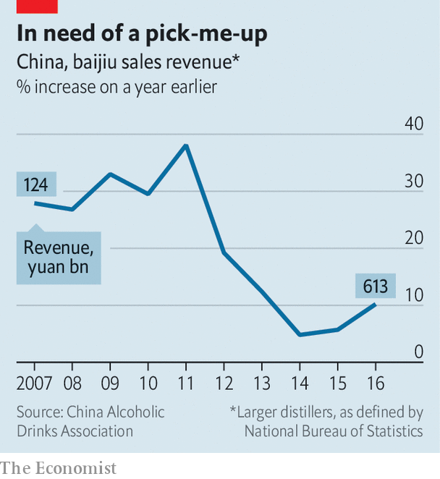
The drama has made them less complacent, prompting a rethink of their export strategies, and much else. In China they are working harder to sell more baijiu to consumers instead of businesses, a task that includes making sure it is well stocked in bars as well as restaurants. They are also wondering how to hedge against worries that young Chinese, and women especially, are not as keen on the stuff as their fathers (one youngster calls baijiu “something your dad drinks”; another says it is “just for drunks”). Minnie Yu, an analyst for Nielsen, a research firm, says distillers are trying to attract younger people with lower-strength versions in smaller bottles. Baijiu companies are aware that they increasingly have to compete in their home market with Western drinks such as gin, whisky and wine. Many have concluded, perhaps correctly, that making their brands look and feel international to Chinese drinkers will help them hold their own against these fashionable foreign tipples. This strategy, rather than the chance of big profits in America, may explain why Wuliangye, another baijiu-maker, has been splashing out on advertising space in New York’s Times Square. Paul Mathew, a baijiu enthusiast who runs Demon, Wise and Partners, a cocktail bar in London, says Chinese firms regularly seek his advice on the British drinks market. But he says their goal is often just to get footage of a foreign bartender making cocktails with their spirit, which they can circulate on social media in China to show that their brand is taken seriously by foreigners. Many distillers see benefit in looking like they are tapping an overseas market—one that never forgot the fragrance from that broken jar.

