A Chinese state-backed giant’s rapid rise in global trading of food
Four-year-old COFCO International is already rivalling Western giants- Print edition | Business Jan 31st 2019
The world of grain trading is a gerontocracy. The four giant firms that dominate global agricultural flows—adm, Bunge, Cargill and Louis Dreyfus, collectively known as the abcds—were all founded over a century ago. Their age is an edge: their unique networks of silos, ports, ships and farmer relationships, built over decades, make them indispensable middlemen. But a toddler from China is threatening to put a pitchfork in the works. cofco International (cil), the overseas trading arm of China’s state-owned food and oil giant, wants to “become a true global agribusiness”, says Chi Jingtao, its chairman. It is barely four years old.
Mr Chi’s aims are not only commercial but strategic. China does not have enough arable land to feed its 1.4bn people. As a rising middle class consumes more meat, that gap worsens, for animal feed is mostly made of grain. One solution from the government has been to buy farmland abroad. Chinese firms have done so in more than 30 countries—China is the largest foreign owner of agricultural land in Australia, for example. But the government soon realised that export bans could render its acquisitions useless, and host countries tightened rules on foreign investment. Instead, China’s leadership is seeking to establish a position in global trading of foodstuffs by building China’s own champion, cil, founded in 2014 as an offshoot of state-owned cofco Group. In that same year China abandoned its official goal of being self-sufficient in soyabeans, indicating that it was prepared to rely on global suppliers for some staples. cil’s main task is to help China source crops directly from overseas farmers. cofcohad done that as the main Chinese importer of global foodstuffs. But managing the domestic market was its focus, whereas cil’s remit is global. There are profits to be made, too, from taking a margin on food imports that have soared 12-fold since 2000, to $117bn in 2017.
cil’s first steps were awkward; it began by buying Nidera of the Netherlands and Hong Kong-based Noble Agri, two traders with a strong presence in South America, for inflated prices. It then neglected to integrate them, and both kept undercutting each other. Then a $200m unauthorised trading loss was found on Nidera’s biofuel desk, followed by a $150m hole in the accounts of its Latin American division. Rivals “thought it hilarious” that the Chinese newbie seemed so clueless, says Jonathan Kingsman, a commodities expert and former Cargill employee. No one is laughing now. cil already earns $34bn in revenue—four-fifths that of Louis Dreyfus, the smallest abcd. It shifts 105m tons of grain, oilseeds and sugar a year, a volume roughly equal to America’s entire production of soyabeans. cil wants to be far more than China’s procurement platform. Already China accounts for less than half of its sales. cil is selling to more than 50 countries, focusing on Europe, the Black Sea and Latin America. Like the abcds, it has invested in massive silos, transport links and processing facilities. It is the fourth-largest soya exporter in Brazil. Latin America remains its most important region for sourcing, but it is also creating export routes from North America and the Black Sea.

Grain drain
The speed of its turnaround has caught the industry off guard. In the first half of 2018, cil reportedly made trading losses of $122m because of wrong-way bets on agricultural markets. It also went through painful staff cuts and a long shutdown at a key port and processing plant. But “the company is probably in much better shape than it seems from the outside”, says Sönke Lorenz of bcg, a consultancy. The trade war has further convinced China of the merchant’s vital role. Last July, China responded to American tariffs on its goods by slapping high duties on American soyabeans, making it too expensive to buy them. This forced China to find a new source for one-third of its $40bn yearly needs—totalling 33m tonnes or four times what all of Southeast Asia consumes. cil did much of the work by finding new suppliers in Brazil. Mr Chi claims that 2019 should be a pivotal year. Last year, after integrating Noble and Nidera in 2017, cil also had to deal with operational problems from the mergers, fallout from the trade war between America and China and severe droughts in Argentina. But the firm is at last in a position “to embrace growth and development”, the chairman argues. He notes that cilachieved profitability last year “for the first time in history” (it does not disclose figures). It will invest in sourcing more grain directly from the world’s breadbaskets, including Russia, Argentina and North America, and it will search for new customers in Europe, the Middle East and South-East Asia, including state-owned entities such as wheat boards, local traders and food processors. cil’s strategy, summarises Mr Chi, “is to leverage our strong presence in China to grow our global business”. The first element is already under way. In December the firm appointed Dong Wei, a 25-year veteran of cofco Group, as chief executive. Mr Dong is an expert in the procurement and processing of soyabeans—a good fit for cil. “His arrival will facilitate the integration of our domestic and international business,” explains Mr Chi.
What worries cil’s big rivals is that the firm’s efforts to dominate direct access to China’s vast market of consumers for grain—both for strategic and business reasons—could have the side-effect of locking them out. For now, they have a prized direct relationship with cofco Group and with other Chinese food manufacturers. “cil could become an unavoidable middleman,” says Jean-François Lambert, a consultant and former head of commodity finance at hsbc, a bank. The abcds can take comfort that their position is still robust. In the markets that count, such as America and Russia, much of the infrastructure used to store, process and ship grain belongs to the established firms. “It’s very difficult, if not impossible, to become an abcdwithout purchasing an abcd,” argues Jay O’Neil of Kansas State University. That may be true in the short term. Two members of the club are private, and adm, the largest of their two listed peers, is nearly twice as big as cil, so would be hard to swallow. Bunge, an American firm that is the weakest of the bunch, may be a good target, but America’s Committee on Foreign Investment in the United States would probably block a Chinese bid.
Still, cil could seek to form alliances with peers to penetrate specific markets. Mr Lambert also suspects the firm could seek to buy a chunk of Louis Dreyfus. (Its owner took a large loan to buy out other shareholders late last year).
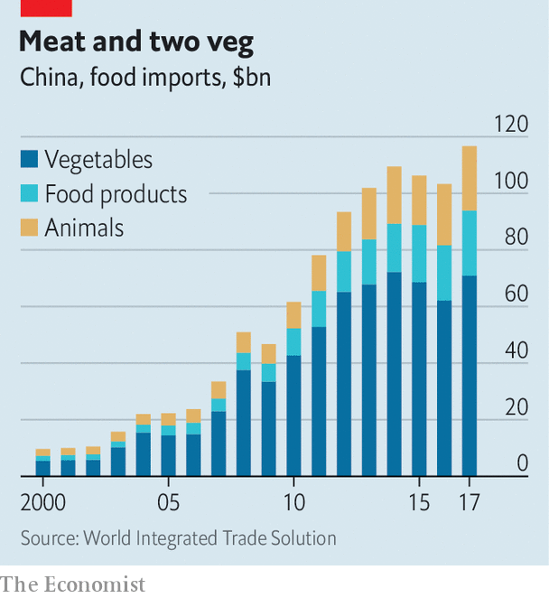
cil must also contend with the fact that its entry into the bulk-commodity trade comes when the activity is hardly profitable. Digitalisation and competition have destroyed margins. The savviest traders are shifting towards value-added products: Cargill makes most of its money from making animal feed and proteins; adm has carved a niche in food ingredients such as sweeteners and colouring. cil needs to master the basic activities first. “This is a young company”, Valmor Schaffer, cil’s Brazil chief, said in November. “At this moment we have other priorities.” That highlights a dilemma for the firm. cil’s primary objective remains “feeding the dragon”, as Mr Lorenz puts it, so it may be ready to accept far lower profits than peers. If the going gets tough, it could also tap the government for cheap back-up capital, insiders suspect.
But the company cannot entirely disregard its bottom line. While state-owned entities own most of cil, minority shareholders include Singapore’s Temasek, the World Bank’s private investment arm and Standard Chartered, a British bank. These took a stake in 2014, when the trader bought Nidera, and all expect a good return. Such pressure is unlikely to abate. Mr Chi says cil could seek to raise more capital to fund its expansion: “Going public is a direction cil is going to take.” When that might happen is a decision for shareholders to make, but an ipo would entail more scrutiny of the company’s results. cil’s game may be a longer one. Trading is an information war: superior insights on global production, prices, inventories and shipping capacity are the sinews of merchants’ profit. Incumbents know this. Cargill in 2017 invested in a startup that analyses satellite images to forecast crop yields. As cil tightens its grip over China’s food market, the world’s largest, its edge could become unmatchable. “Everything starts and ends with Chinese demand,” says a former abcd executive. “Understand what the biggest national buyer is doing, and you control the trading game.”

